**TASK 4 SIMPLE QUERY PART 2**

1. [SELECT](http://localhost/phpmyadmin/url.php?url=https://dev.mysql.com/doc/refman/8.0/en/select.html) * FROM `obat` ORDER BY nama_obat DESC;
2. 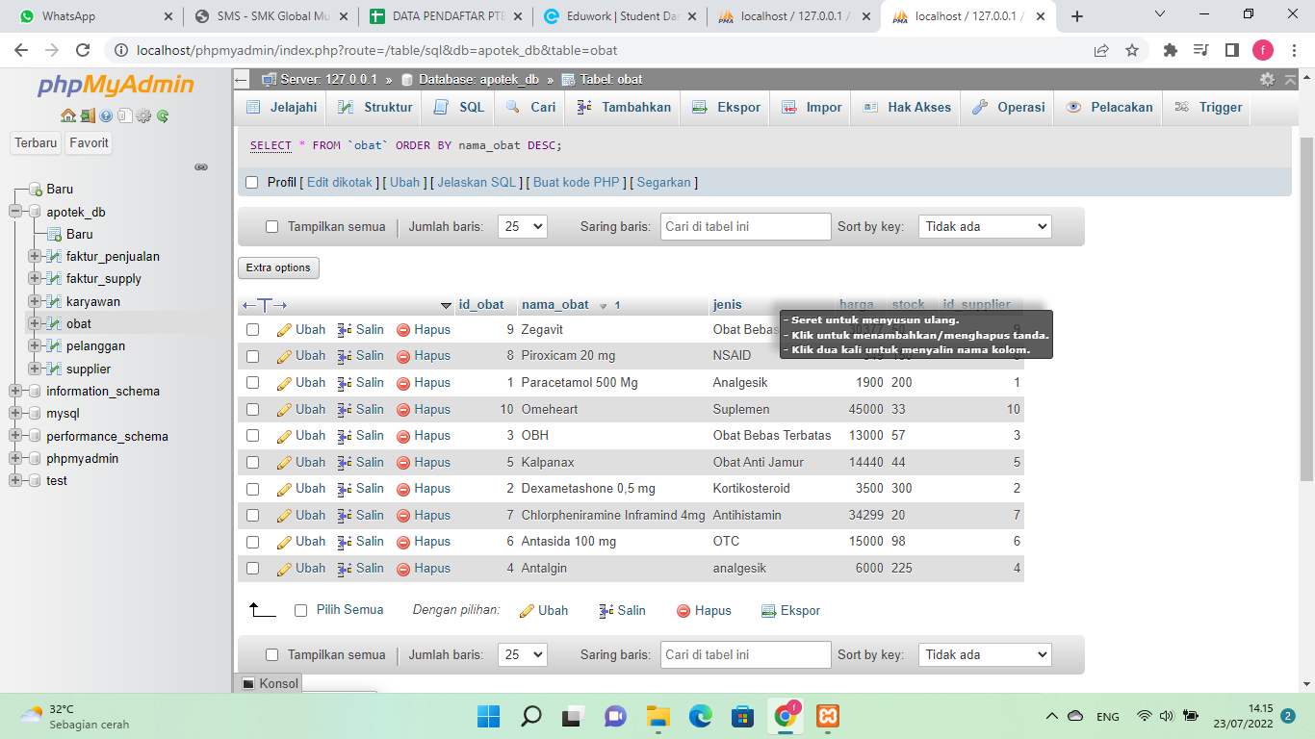
3. [SELECT](http://localhost/phpmyadmin/url.php?url=https://dev.mysql.com/doc/refman/8.0/en/select.html) * FROM `obat` ORDER BY jenis ASC;

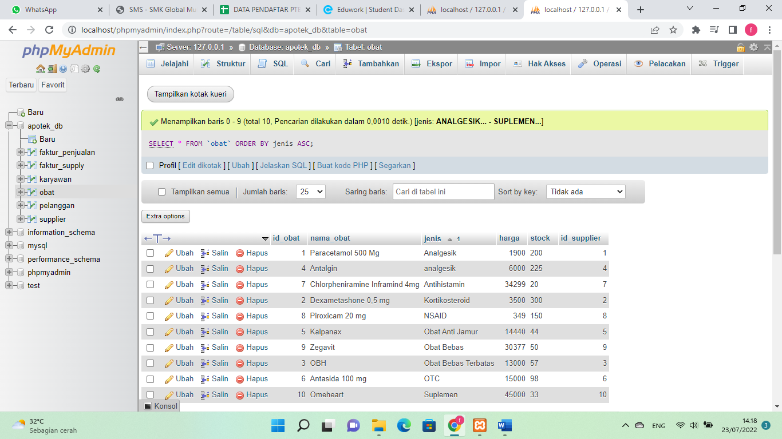

1. [SELECT](http://localhost/phpmyadmin/url.php?url=https://dev.mysql.com/doc/refman/8.0/en/select.html) * FROM `karyawan` WHERE alamat [LIKE](http://localhost/phpmyadmin/url.php?url=https://dev.mysql.com/doc/refman/8.0/en/string-comparison-functions.html%23operator_like) '%Cikarang%';

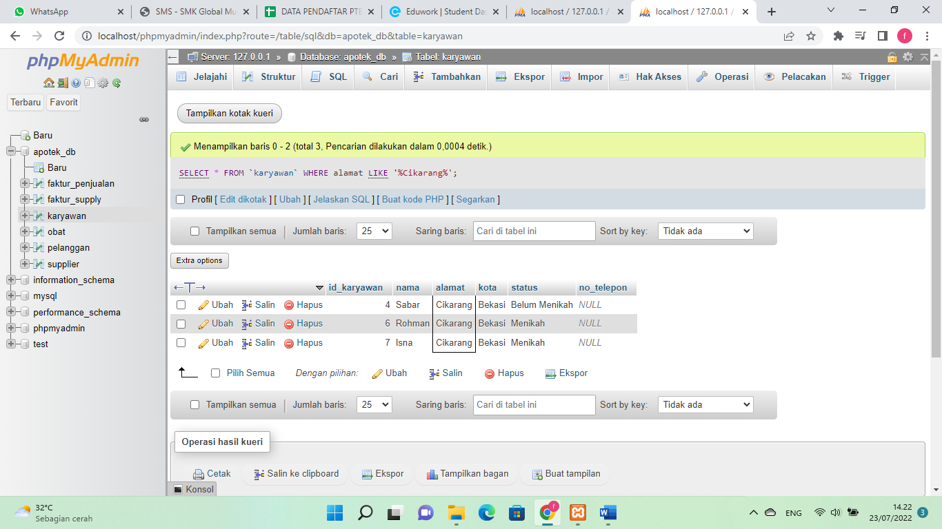

1. [SELECT](http://localhost/phpmyadmin/url.php?url=https://dev.mysql.com/doc/refman/8.0/en/select.html) * FROM `karyawan` WHERE kota [LIKE](http://localhost/phpmyadmin/url.php?url=https://dev.mysql.com/doc/refman/8.0/en/string-comparison-functions.html%23operator_like) '%Bekasi%';

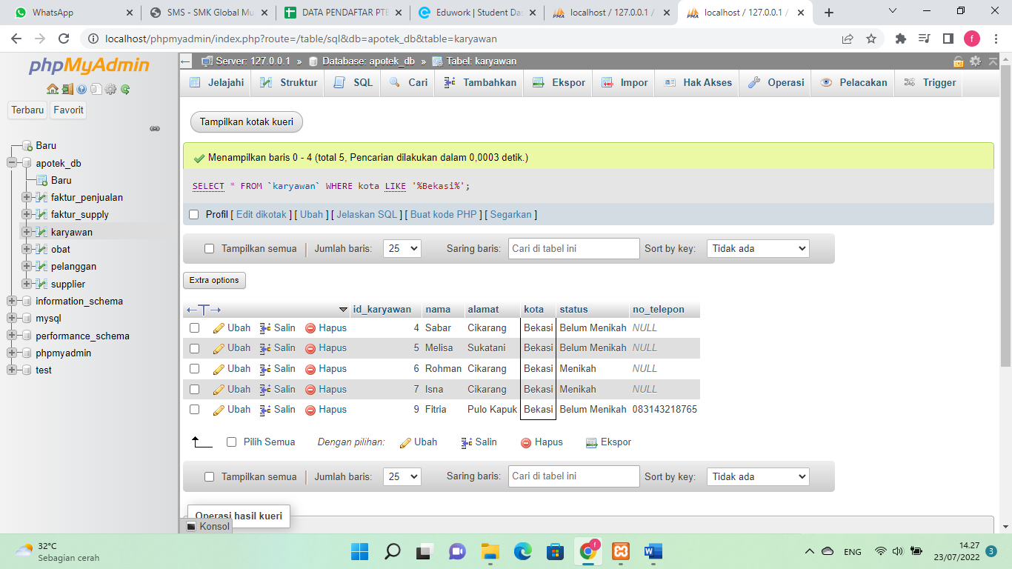

1. [SELECT](http://localhost/phpmyadmin/url.php?url=https://dev.mysql.com/doc/refman/8.0/en/select.html) id_pelanggan, [SUM](http://localhost/phpmyadmin/url.php?url=https://dev.mysql.com/doc/refman/8.0/en/aggregate-functions.html%23function_sum)(jumlah) as total_pembelian FROM `faktur_penjualan` GROUP BY id_pelanggan;

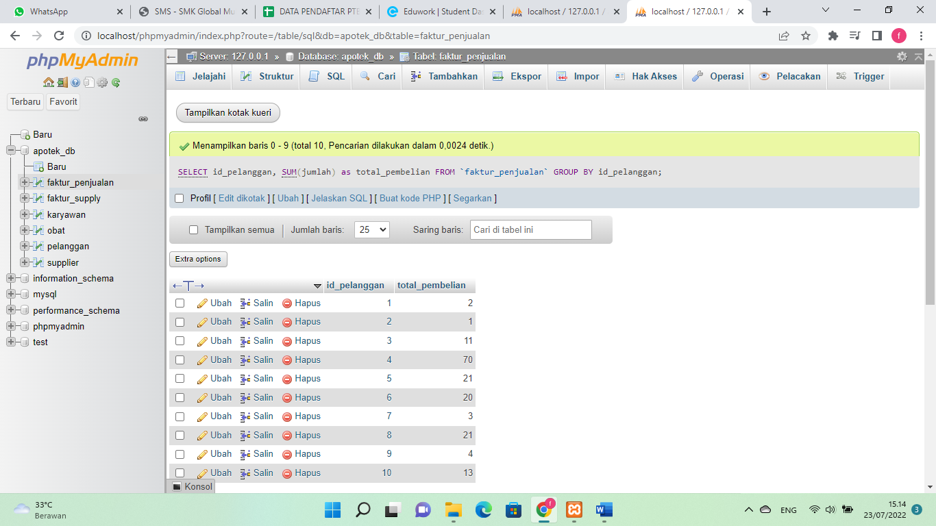

1. [SELECT](http://localhost/phpmyadmin/url.php?url=https://dev.mysql.com/doc/refman/8.0/en/select.html) id_obat, [SUM](http://localhost/phpmyadmin/url.php?url=https://dev.mysql.com/doc/refman/8.0/en/aggregate-functions.html%23function_sum)(jumlah) as total_pembelian FROM `faktur_penjualan` GROUP BY id_obat;

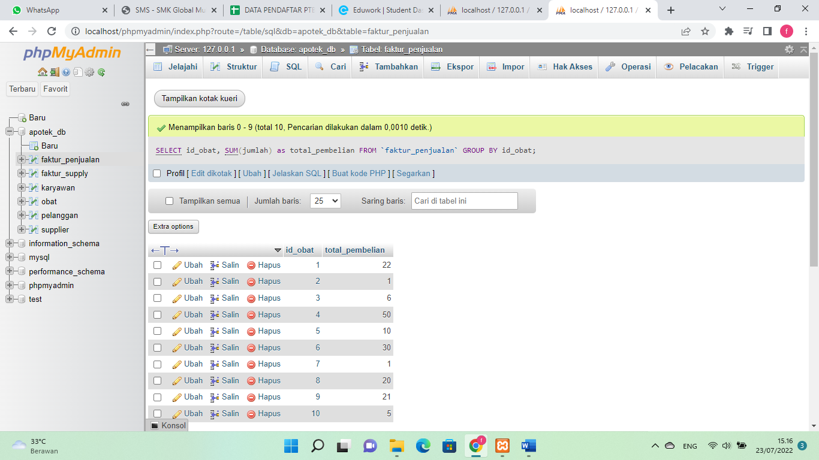

1. [SELECT](http://localhost/phpmyadmin/url.php?url=https://dev.mysql.com/doc/refman/8.0/en/select.html) tanggal, [SUM](http://localhost/phpmyadmin/url.php?url=https://dev.mysql.com/doc/refman/8.0/en/aggregate-functions.html%23function_sum)(jumlah) as total_pembelian FROM `faktur_penjualan` WHERE tanggal [LIKE](http://localhost/phpmyadmin/url.php?url=https://dev.mysql.com/doc/refman/8.0/en/string-comparison-functions.html%23operator_like) '%2022-07-23%' GROUP BY tanggal ASC;

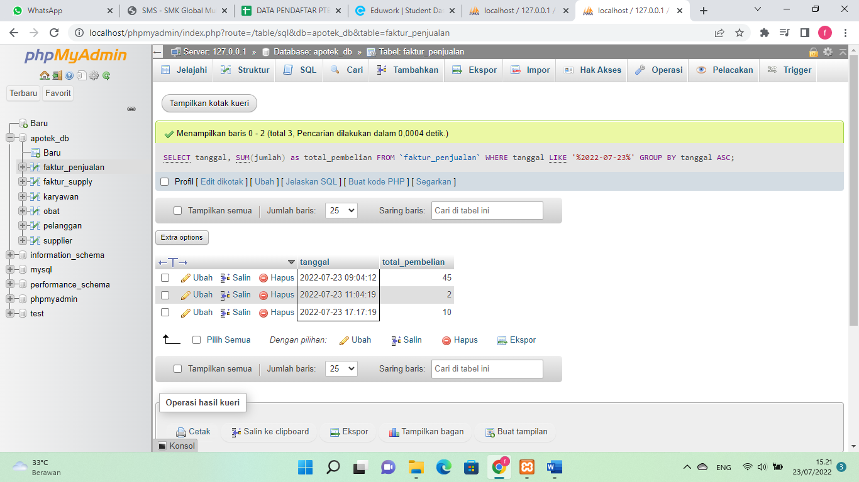

1. [SELECT](http://localhost/phpmyadmin/url.php?url=https://dev.mysql.com/doc/refman/8.0/en/select.html) id_karyawan, [SUM](http://localhost/phpmyadmin/url.php?url=https://dev.mysql.com/doc/refman/8.0/en/aggregate-functions.html%23function_sum)(jumlah) as total_penjualan FROM faktur_penjualan WHERE id_karyawan <= 3 GROUP BY id_karyawan ORDER by id_karyawan ASC;

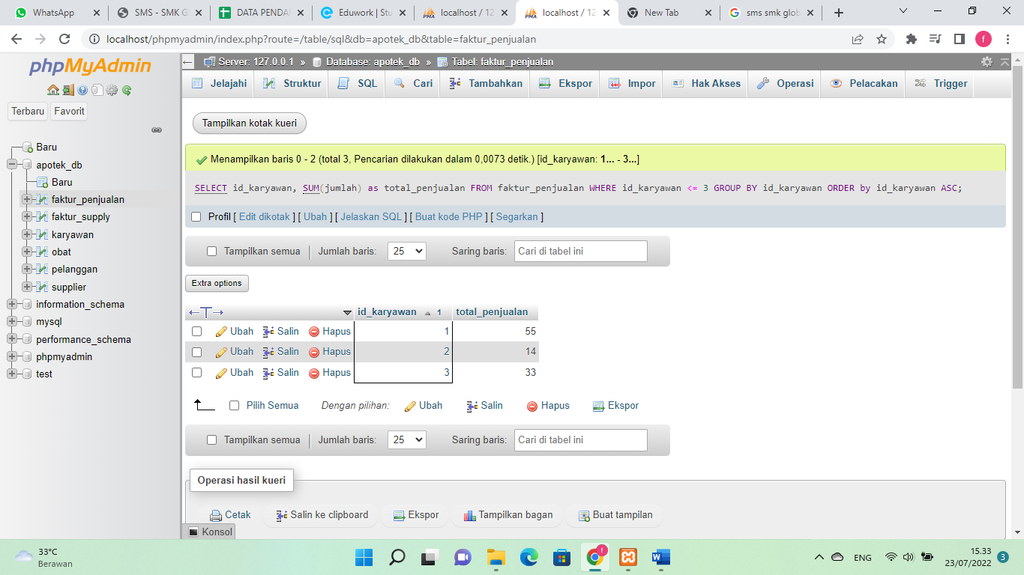

1. [SELECT](http://localhost/phpmyadmin/url.php?url=https://dev.mysql.com/doc/refman/8.0/en/select.html) id_obat, [SUM](http://localhost/phpmyadmin/url.php?url=https://dev.mysql.com/doc/refman/8.0/en/aggregate-functions.html%23function_sum)(jumlah) as total_penjualan FROM faktur_penjualan WHERE id_obat = 3 GROUP BY id_obat;

